Live Q&A 3 Transcript

Preliminaries

What do we need to bring for our first SGT on campus?
- Safety – facemasks, sanitizer.
- Your laptop for notes.

Itempool Quiz

What’s wrong with the code?
public class CokeMachine
{
private int price;

public CokeMachine()
{
price = 300;
}

public int getPrice()
{
return Price;
}
}
- (All mistakes are in red)
- INDENT YOUR CODE!
- Casing is important. Java treats price and Price as two different variables.

What will be printed?
System.out.println(5 + 6 + "hello");
System.out.println("hello" + 5 + 6);
- 11hello hello56
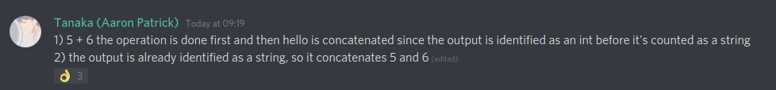
(join us on Discord! https://discord.gg/X7zvwVX)

What will be printed?
System.out.println("hello" + 5 * 6);

- hello30

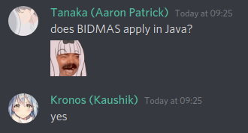

What will be printed?
System.out.println(("hello" + 5) * 6);

- This is an error.
- String multiplication is undefined

What does this code segment output?
int number = 42;
if (number = 42)
number = number + 1;
number = number + 2;
System.out.println(number);
- This code will not compile.
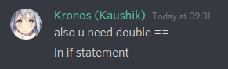

What does this code segment output?
int number = 42;
if (number == 42)
number = number + 1;
number = number + 2;
System.out.println(number);
- 45
- It begins with 42 + 1 = 43, then 43 + 2 = 45.

What does this code segment output?
int number = 42;
if (number != 42)
number = number + 1;
number = number + 2;
System.out.println(number);
- 44
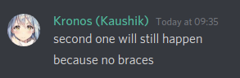

Questions & Answers

What is the standard for naming variables with more than one word?
We typically capitalise the next word.

How do you distinguish a constructor and a method?
There are two things:
- The constructor is always the same name as the class
- There is no return type

Can parameters have the same name as the fields?
They can. Just make sure to differentiate using this.[fieldname]
It starts searching for the variable in the closest enclosing scope.
Or you could use different parameter names for field names.

Should you always use this.?
Only use it if you need it.

Can methods use other methods?
This is answered in this week’s video.

How do we know we passed the reflection quizzes?
As long as you attempted them, you’re fine.

Final words
If you have any piece of code you want to know happens, try it out in BlueJ!
Kindly go on KEATS and give feedback for your teaching. This is beneficial for us and for you!
https://keats.kcl.ac.uk/mod/feedback/view.php?id=4566096

Discord Highlights
Some highlights from the live chat from our Discord channel.
(join us on Discord! https://discord.gg/X7zvwVX)
